Analysis steps

1. 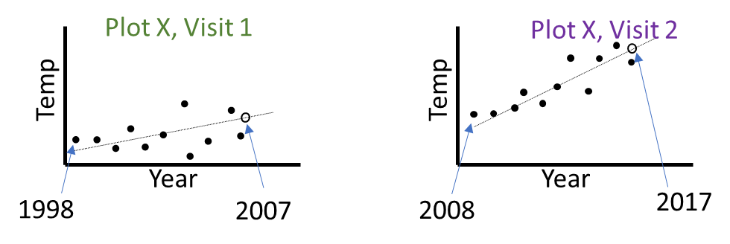Predict temperature or precipitation values for first and second visit at all FIA plots occupied by target species of interest.
2. Using only the first visit predicted temperature or precipitation values, conduct range shift analysis. Range shift = mean of temperature/precipitation values for plots occupied in visit 2 – visit 1.

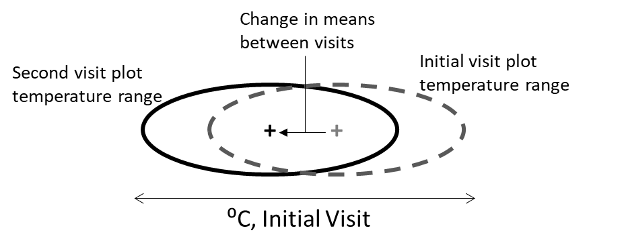

1. Using only the first visit predicted temperature or precipitation values and the FIA plots at which a species either lost or gained individuals between visits, conduct density shift analysis. Density shift = mean of temperature/precipitation values for plots that gained trees – those that lost trees.
2. Using all FIA plots occupied by a species at either visit and the predicted temperature or precipitation values for visit 1 and visit 2, we examined changes in temperature or precipitation across plots.

